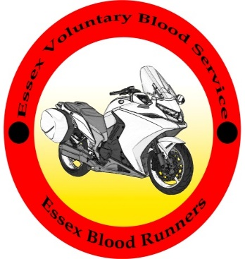 | Essex Voluntary Blood Service  Essex Bloodrunners

(Please print your details CLEARLY and ACCURATELY – Thank you)

Your personal details
Title (Mr. Mrs. Ms. Miss – Other)
Surname
First name
Middle names
Preferred / nickname
Age
Occupation

House /flat name/number
Road name
Area
Town
County
Post Code

Home phone number
Work phone number
Mobile phone number
email address
Reflective tabard size | S / M / L / XL / XXL / XXXL

Next of kin
Title (Mr. Mrs. Ms. Miss – Other)
Surname
First name
Relationship

House /flat name/number
Road name
Area
Town
County
Post Code

Home phone number
Work phone number
Mobile phone number

Please continue on page 2
Page 2

Vehicle Details
Bike 1 Type
Bike 1 Registration number
Bike 2 Type
Bike 2 Registration number

Car 1 Type
Car 1 Registration number
Car 2 Type
Car 2 Registration number

Driving Licence number
AA membership number
RAC membership number
Another rescue organisation

Voluntary duties offered (Please put a X for any of the following that you are prepared to help with)

Duty Rider/Driver |  |  | Collectors
Weekly Controller |  |  | General
Route Training |  |  | Charity days
Emergency stand-by |  |  | Publicity
EHAAT duty |  |  | Breakfast Run Duty
Hearts milk bank run |  |  | Addenbrookes milk run
Operation Vampire run |  |  | Raising funds

We do rota via Doodle Poll this is sent out every few months for members to click which dates they would like to be on rota.

Please email to evbs-applicants@hotmail.com

Please send a passport size head shot of yourself for your ID

If posting, send to:
Mrs C A Weller 4 Cracknell Close Wivenhoe Essex CO7 9PY

Once we have received your application form, we will contact you by email to arrange to bring you in for our GMP training session. This takes about 2 hours on an evening of your choice; it is held in Wivenhoe Essex. Please jot down any questions or queries you may have in the space below so that we can go through them with you at your training session.

